C++ ASST-1(WEEK-1 CODES)

-V.Phalgun

AP21110010223

CSE-D

1.OPERATORS CODE:

#include<iostream>

using namespace std;

int num1,num2,sum,diff,product,quotient,remainder;

char choice;

int main()

{

cout<<"Enter the First Integer- "<<endl;

cin>>num1;

cout<<"Enter the Second Integer- "<<endl;

cin>>num2;

cout<<"Enter the choice of operand- "<<endl;

cin>>choice;

switch(choice)

{

case '+': cout<<"The Operation selected is Addition."<<endl;

sum=num1+num2;

cout<<"The Summation is "<<sum<<endl;

break;

case '-': cout<<"The Operation selected is Subtraction."<<endl;

diff=num1-num2;

cout<<"The Difference is "<<diff<<endl;

break;

case '\*': cout<<"The Operation selected is Multiplication."<<endl;

product=num1\*num2;

cout<<"The Product is "<<product<<endl;

break;

case '/': cout<<"The Operation selected is Division."<<endl;

quotient=num1/num2;

cout<<"The Quotient is "<<quotient<<endl;

break;

case '%': cout<<"The Operation selected is Modular Division."<<endl;

remainder=num1%num2;

cout<<"The Remainder is "<<remainder<<endl;

break;

}

return 0;

}

OUTPUT:

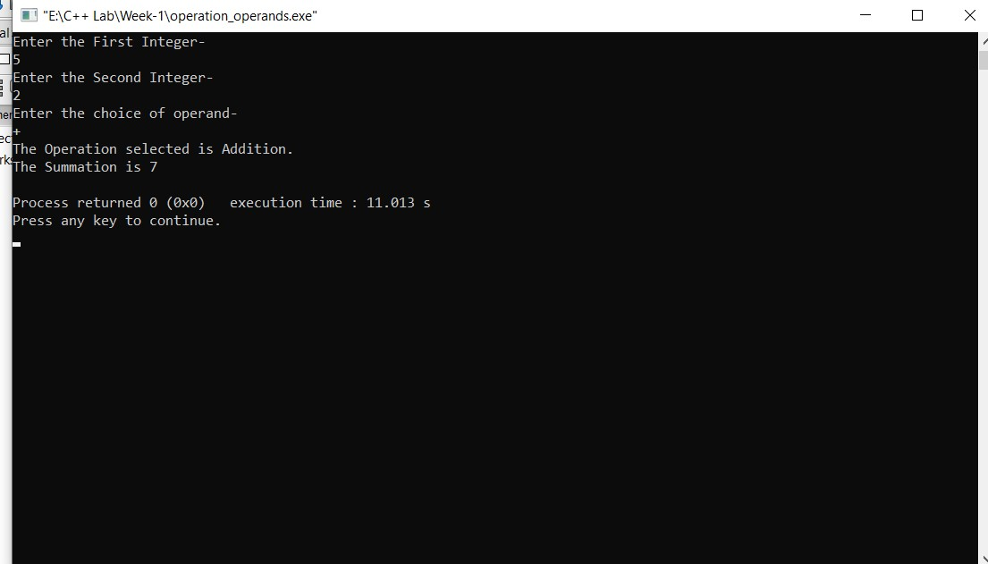

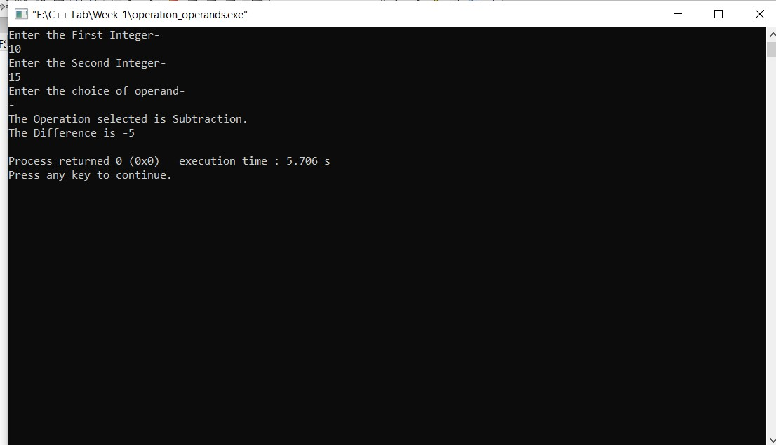

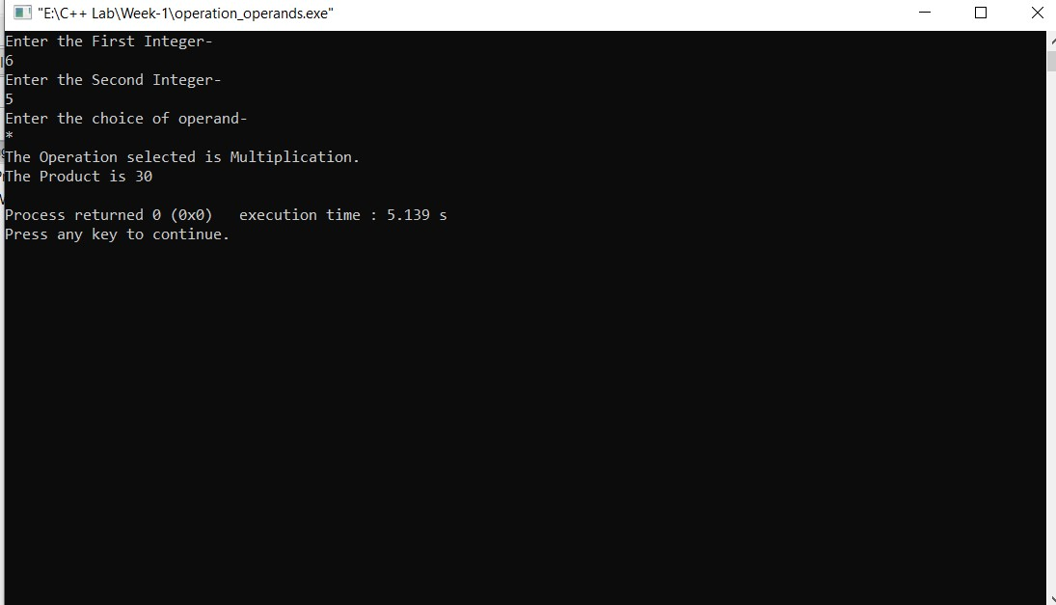

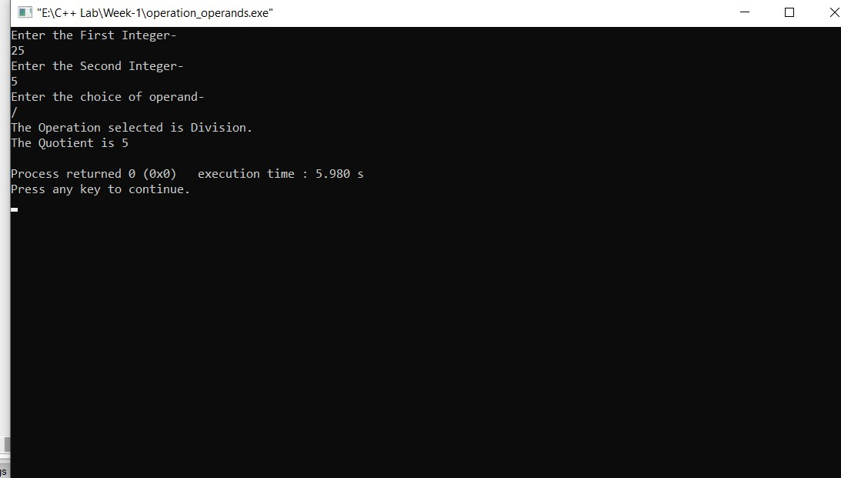

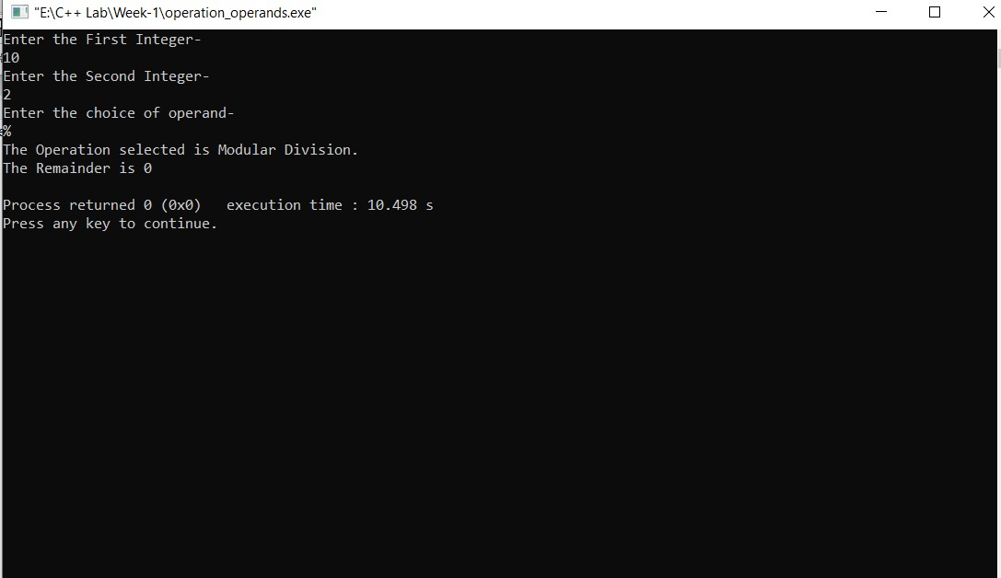

2.PRIME NUMBERS CODE:

#include<iostream>

using namespace std;

int main()

{

int i,j,isPrime,n;

cout<<"Enter the value of n= ";

cin>>n;

for(i=2;i<=n;i++)

{

isPrime=0;

for(j=2;j<=i/2;j++)

{

if(i%j==0)

{

isPrime=1;

break;

}

}

if(isPrime==0&&n!=1)

cout <<i<<endl;

}

return 0;

OUTPUT:

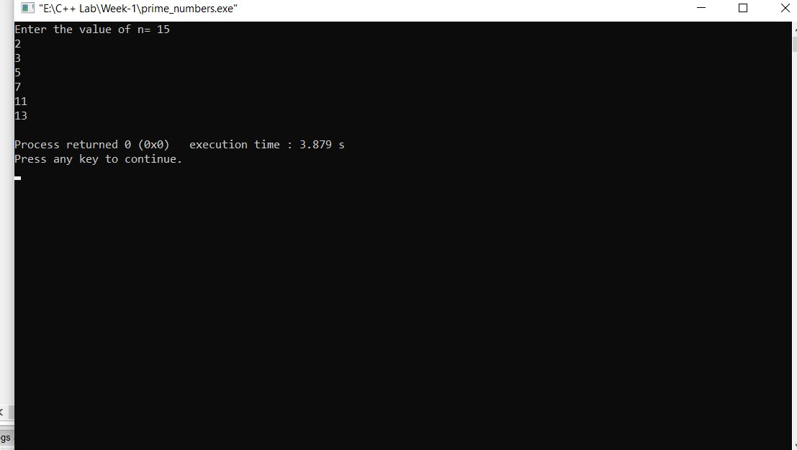

3.SEARCHING AN ARRAY CODE:

#include<iostream>

using namespace std;

int main()

{

int a[100],i,n,pos,sear;

cout<<"Enter how many elements you wish to store in the array"<<endl;

cin>>n;

cout<<"Enter the elements into array"<<endl;

for(i=0;i<n;i++)

{

cin>>a[i];

}

cout<<"Enter the search element"<<endl;

cin>>sear;

for(i=0;i<n;i++)

{

if(a[i]==sear)

{

pos=i;

break;

}

}

if(i==n)

{

cout<<"Element is not found in the array"<<endl;

}

else

{

cout<<"The Position of the Element is:"<<pos<<endl;

}

return 1;

}

OUTPUT: 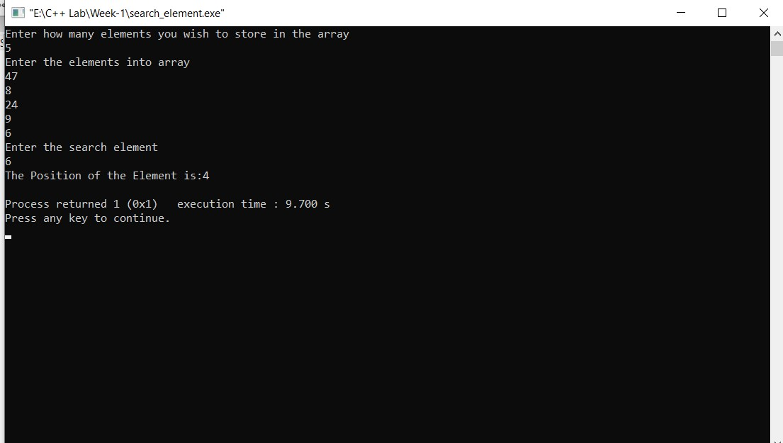

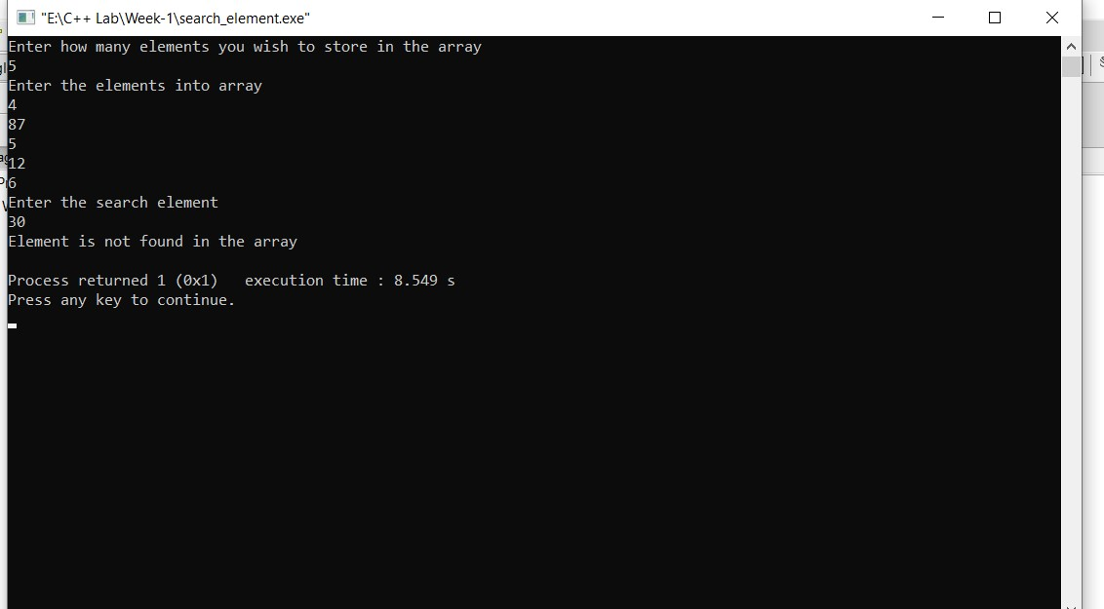

4.FACTORIAL CODE:

#include<iostream>

using namespace std;

int main()

{

int n,i,fact=1;

cout<<"Enter the value of n: "<<endl;

cin>>n;

for(i=n;i>0;i--)

{

fact=fact\*i;

}

cout<<"Factorial of Entered Number n is "<<fact<<endl;

return 0;

}

OUTPUT:

